Written Assignment Unit 2
1. Determine whether the lines given by the equations below are parallel, perpendicular, or neither. Also, find a rigorous algebraic solution for each problem.

a.
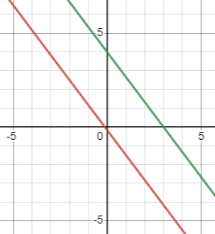
From the graph, it is evident that the two linear equations are parallel.
Algebraic solution
$3y+4x=12$ ….… (i)
$-6y=8x+1$ ……..(ii)
Re-writing equation (i), $y=-\frac{4}{3}x+4$, hence and $m_{1}=-\frac{4}{3}$
Re-writing equation (i), $y=-\frac{4}{3}x-\frac{1}{6}$, hence and $m_{2}=-\frac{4}{3}$
Since $m_{1}=m_{2}$, we can conclude that the two equations are parallel to each other, which matches what has been displayed on the graph.

b.
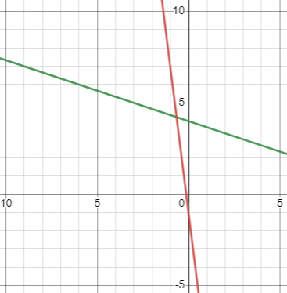
From the graph, it is evident that the two linear equations are neither parallel nor perpendicular.
Algebraic solution
$3y+x=12$ ….… (i)
$-y=8x+1$ ……..(ii)
Re-writing equation (i), $y=-\frac{1}{3}x+4$, hence and $m_{1}=-\frac{1}{3}$
Re-writing equation (i), $y=-8x-1$, hence and $m_{2}=-8$
Since $m_{1}≠m_{2}$, we can conclude that the two equations are not parallel to each other, which matches what has been displayed on the graph.

c.
From the graph, it is evident that the two linear equations are perpendicular to each other.
Algebraic solution
$4x-7y=10$ ….… (i)
$7x+4y=1$ …….. (ii)
Re-writing equation (i), $y=\frac{4}{7}x-\frac{10}{7}$, hence and $m_{1}=\frac{4}{7}$
Re-writing equation (i),$y=-\frac{7}{4}x-\frac{1}{4}$ , hence and $m_{2}=-\frac{7}{4}$
Since $m_{1}×m_{2}=-\frac{7}{4}×\frac{4}{7}=-1$, we can conclude that the two equations are perpendicular to each other, which matches what has been displayed on the graph.

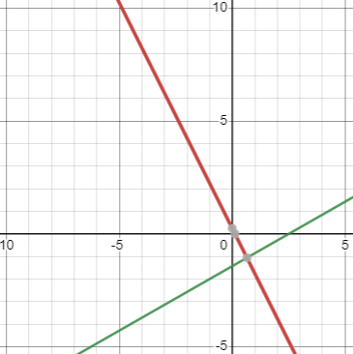

2. A ball is thrown in the air from the top of a building. Its height, in meters above ground, as a function of time, in seconds, is given by . What is the height of the building? What is the maximum height reached by the ball? How long does it take to reach maximum height? Also, find a rigorous algebraic solution for the problem.
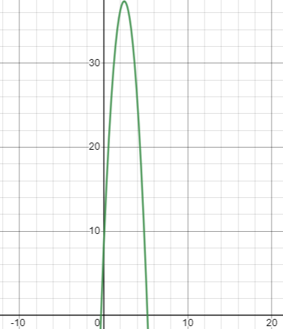
Height of the Building:
The height of the building is equal to the y-intercept, which can be obtained by solving h(0).
$h\left(0\right)=-4.9{\left(0\right)}^{2}+24\left(0\right)+8$
$h\left(0\right)=0+0+8$
$h\left(0\right)=8$
Maximum Height Reached by the Ball:
Standard quadratic equation can be written as $h\left(t\right)=a(t-h)^{2}+k$, where (h, k) is the vertex of the parabola.
Therefore, $h\left(t\right)=-4.9t^{2}+24t+8=-4.9(t - 2.45)^{2} + 37.39$
$h=2.45$ and$k=37.39$
Therefore, the maximum height reached by the ball is approximately 37.39m.
Alternatively,
$h=-\frac{b}{2a}=-\frac{24}{2\left(4.9\right)}≈2.45$
$k=h\left(2.45\right)=-4.9{\left(2.45\right)}^{2}+24\left(2.45\right)+8≈37.39$
Therefore, maximum height $≈37.39$
Time to Reach Maximum Height:
This has already been calculated, which is represented by the value of h from the vertex of the parabola. Therefore, the ball reaches its maximum height after approximately $t = 2.45$ seconds from the time it was launched.
3. In a market, there are 100 shops, and a shop’s average per day income is $200. If one more shop is added to the market, the average income per shop reduces by $5 due to price competition. Conversely, the decrease of one shop can increase the average income per shop by $5 due to cartelization among the shopkeepers. Please suggest the optimal number of shops to the city’s revenue department from a total income (revenue) point of view of the market?
Let Q represent the number of shops, and p the daily revenue per shop. When modelling the linear equation for the cost, $Q=mp+b$
$m=\frac{101-100}{195-200}=-\frac{1}{5}$
$Q=-\frac{1}{5}p+b$ ……………. (i)
Substituting the pair $(p,Q)$into $(i)$
$100=-\frac{1}{5}(200)+b$
$b=140$
Therefore, the linear equation becomes $Q=-\frac{1}{5}p+140$
Total daily revenue $=Qp$, therefore:
$Qp=p(-\frac{1}{5}p+140)$
$revenue=-\frac{1}{5}p^{2}+140p$
$h=-\frac{b}{2a}=-\frac{140}{\left(-\frac{2}{5}\right)}=350$
$maximum revenue=-\frac{1}{5}{\left(350\right)}^{2}+140\left(350\right)=\$24,500$, which occurs when there are 350 shops.

